**Session: Introduction to Linux**

**Name: Ahan Jain**

**EmpID: 8202**

**1. Create a directory "exercise" inside your home directory and create a nested (dir1/dir2/dir3) directory structure inside "exercise" with a single command.**

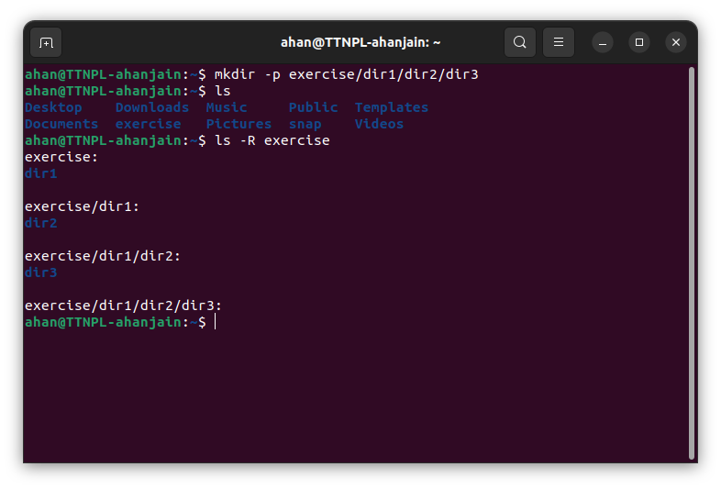

**a. Create two empty files inside the dir2 directory: emptyFile1, emptyFile2 in single command.**

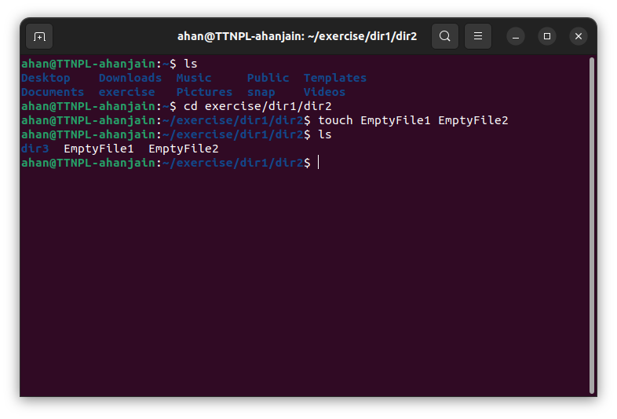

**b. Change the timestamp of empty File1, emptyFile2 which exist in dir2.**

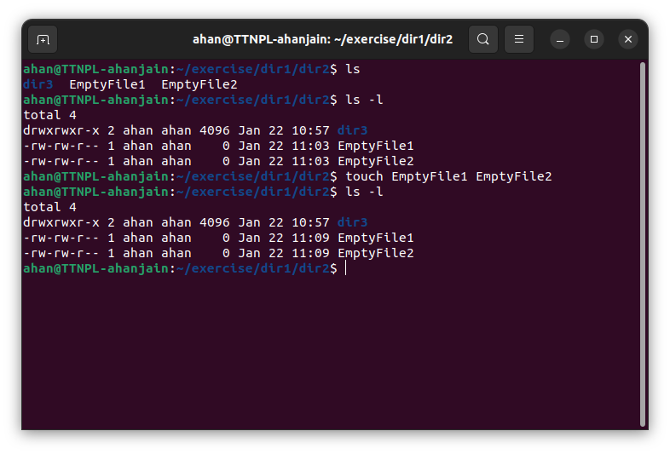

**c. Create one file file1.txt containing text "hello world" and save it.**

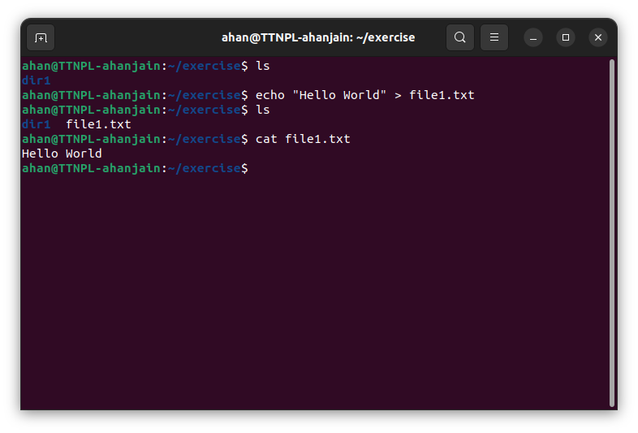

**2. Find a "passwd" file using find command inside /etc. copy these files as passwd_copy and then rename this file as passwd_backup.**

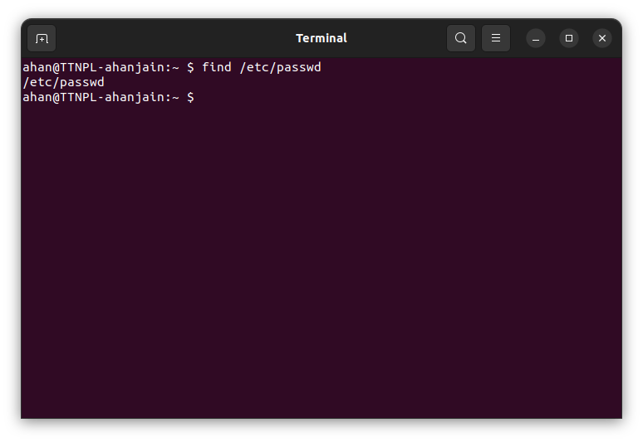

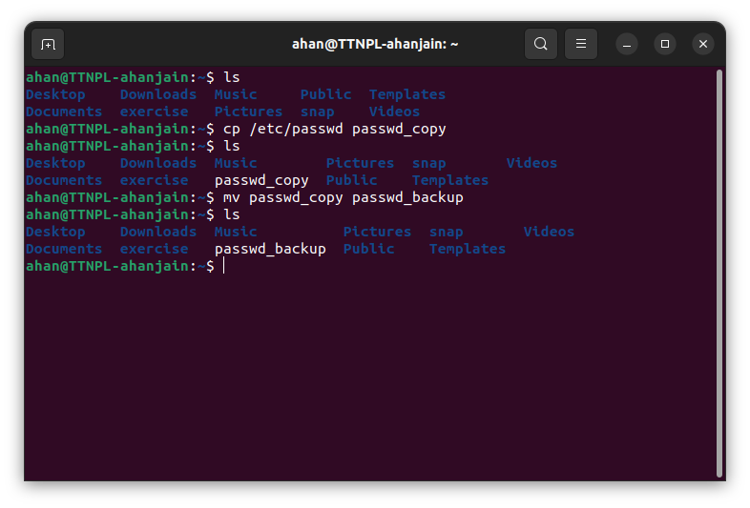

**a. Try reading the passwd_backup file in multiple tools: less,more,cat,strings etc and find the difference in their usage.**

**Less**

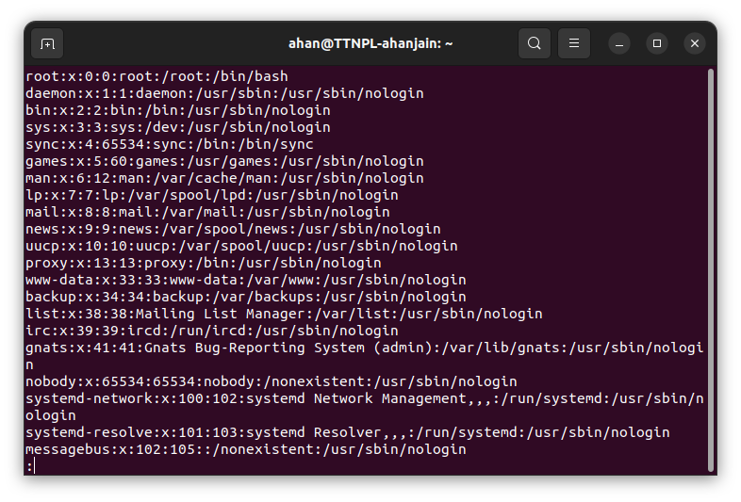

**More**

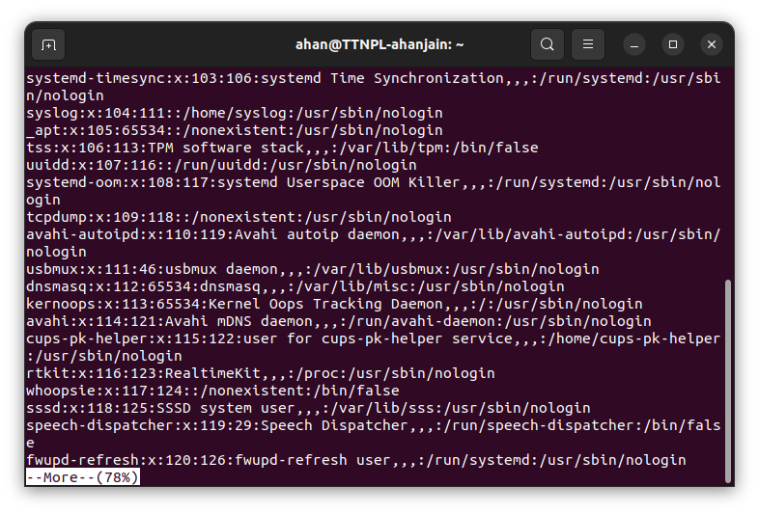

**Tail and Head**

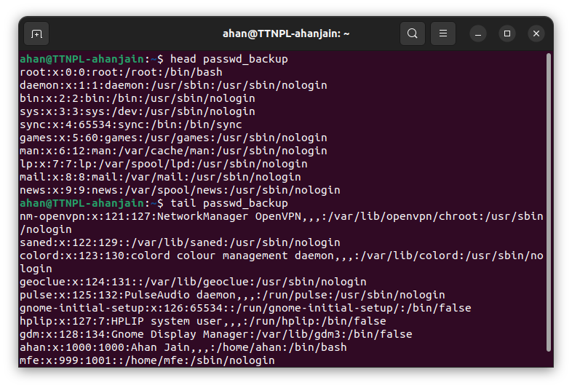

**Cat**

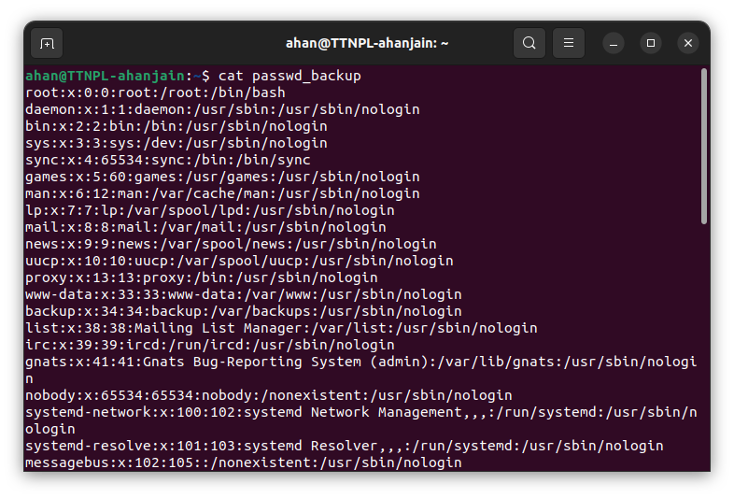

**Strings**

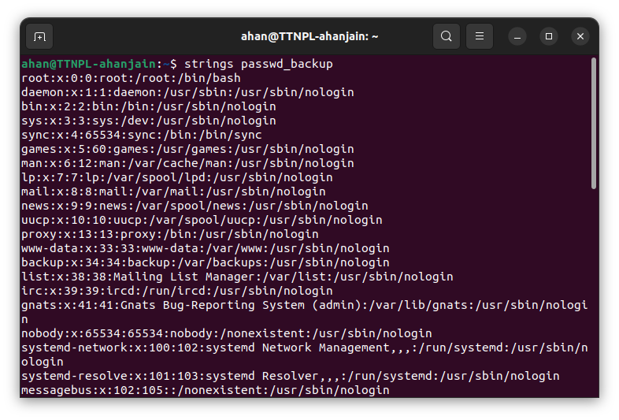

| **Less** | View large files interactively |
| --- | --- |
| **More** | View files one screen at a time |
| **Head** | Display first lines of a file |
| **Tail** | Display last lines of a file |
| **Cat** | Concatenate and display files |
| **Strings** | Extract text from files |

**b. Find out the number of lines in password_backup containing "/bin/false".**

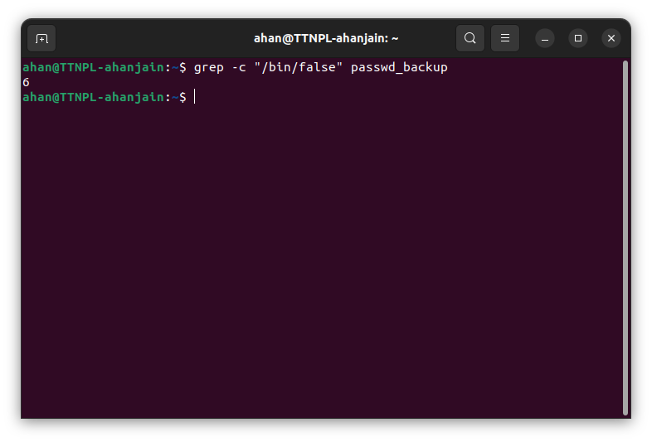

**c. Get the first 5 lines of a file “password_backup” and Redirect the output of the above commands into file "output". Also, get the lines 6-10 from the above file.**

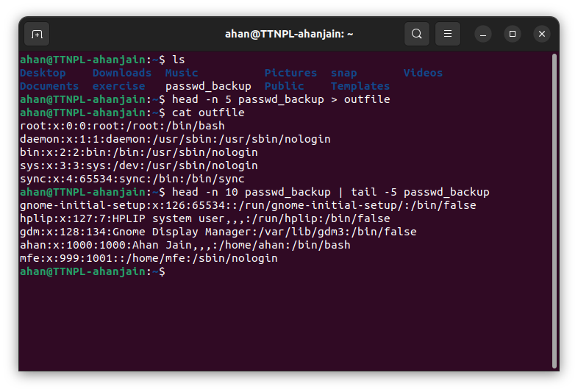

**3. Create a "test" user, create its password and find out its uid and gid.**

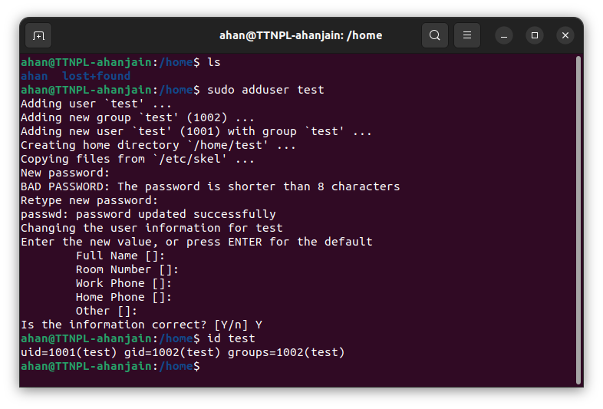

**a. Login as test user and edit the "output" file created above. Since the permission won't allow you to save the changes. Configure such that the test user can edit it.**

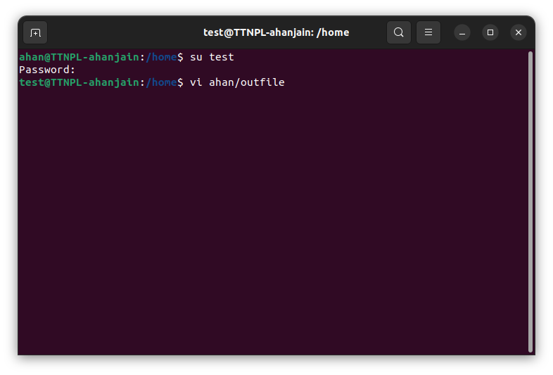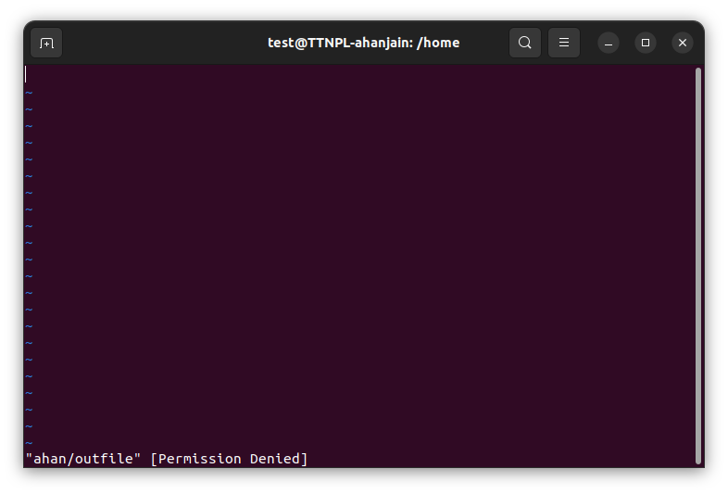

**b. Add the group owner of the "output" file as the secondary group of test user and check/change the "output" file permission if it is editable by group. Once done revert the changes.**

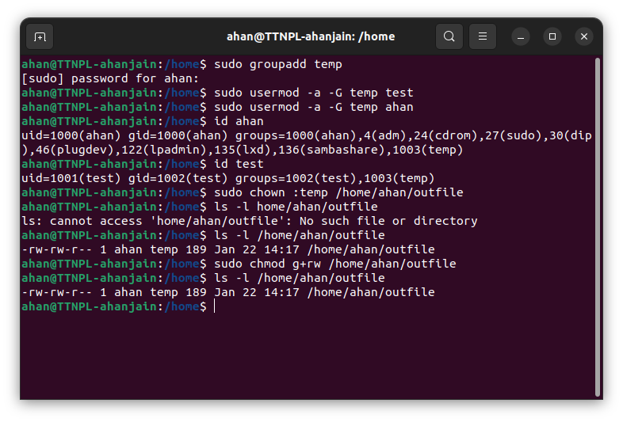

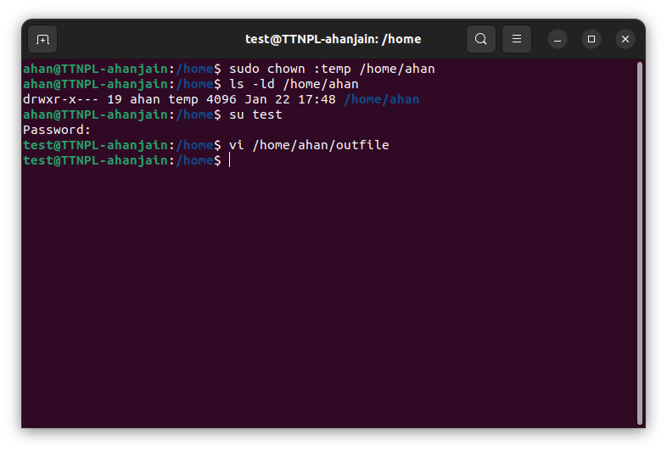

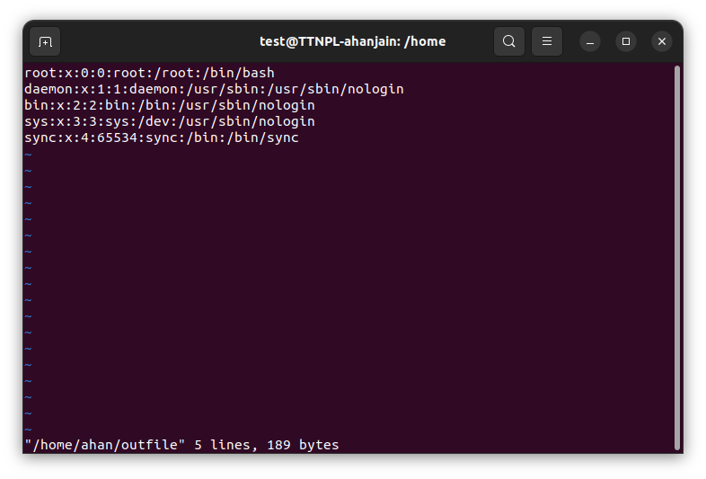

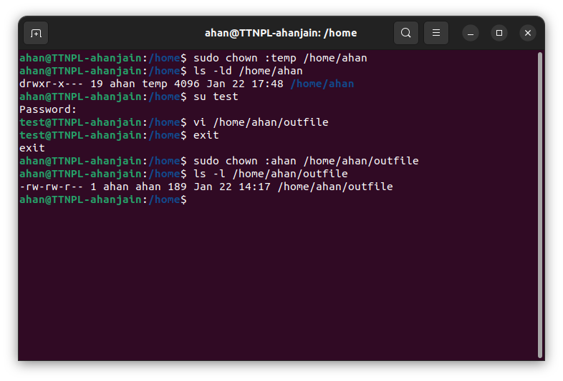

**c. Make the file editable to the world so that test user can access it. Revert the changes after verification**

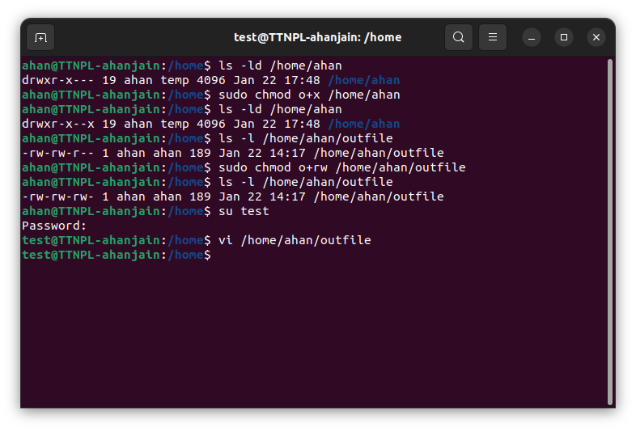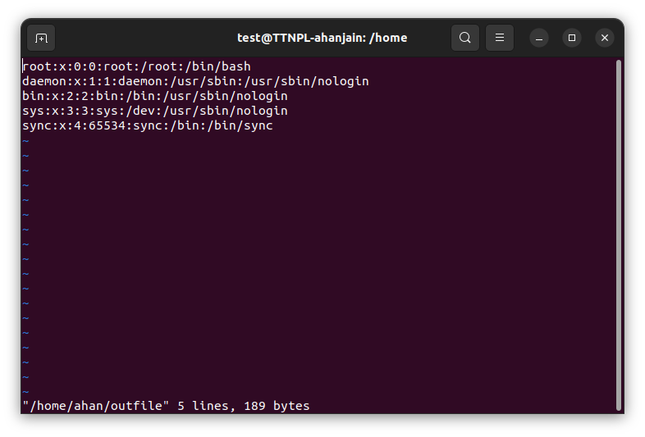

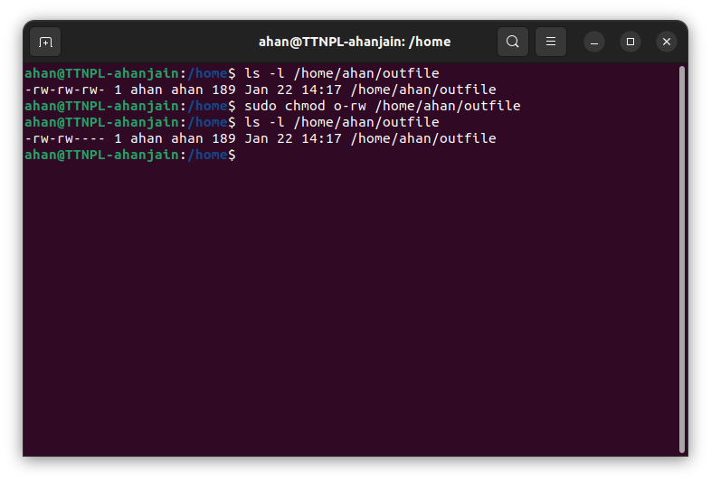

**d. Change the ownership to edit the file.**

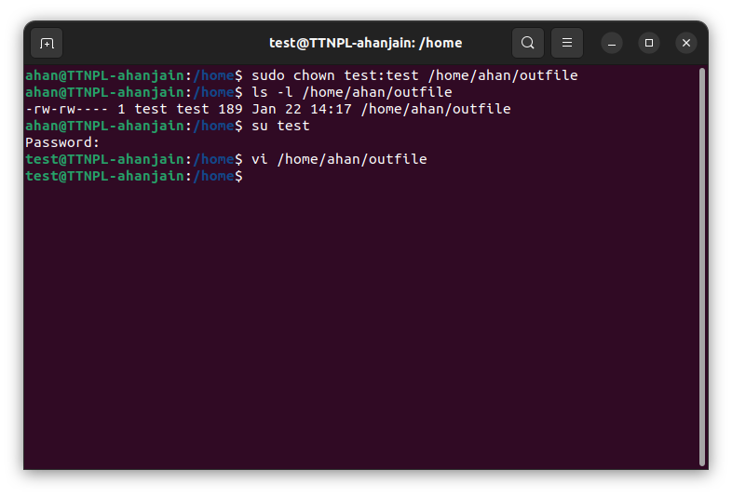



**11. Create an alias with your name so that it creates a file as "/tmp/aliastesting"**.

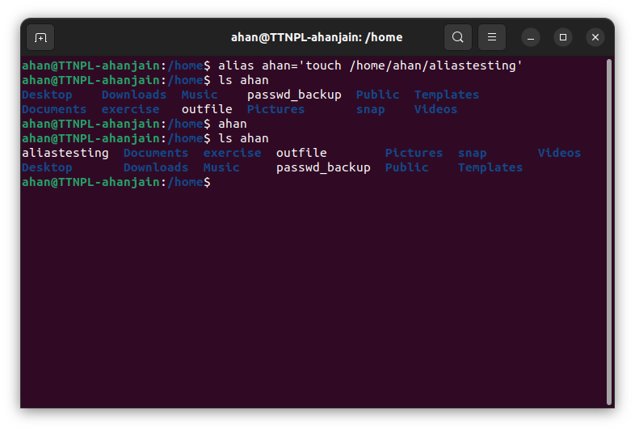

**12. Edit ~/.bashrc file such that when you change to "test" user it should clear the screen and print "Welcome".**

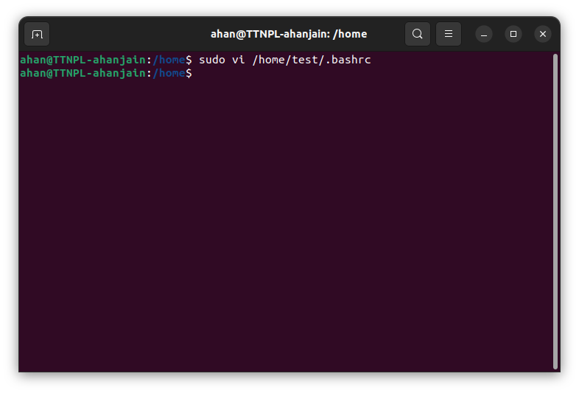

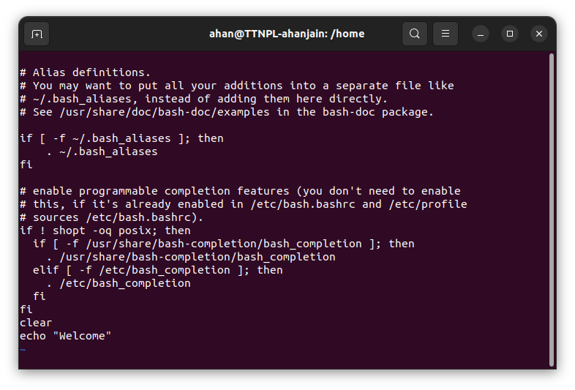

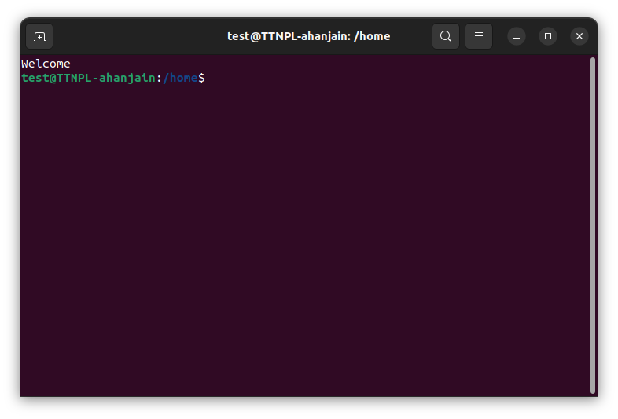

**13. Install “zip” package.**

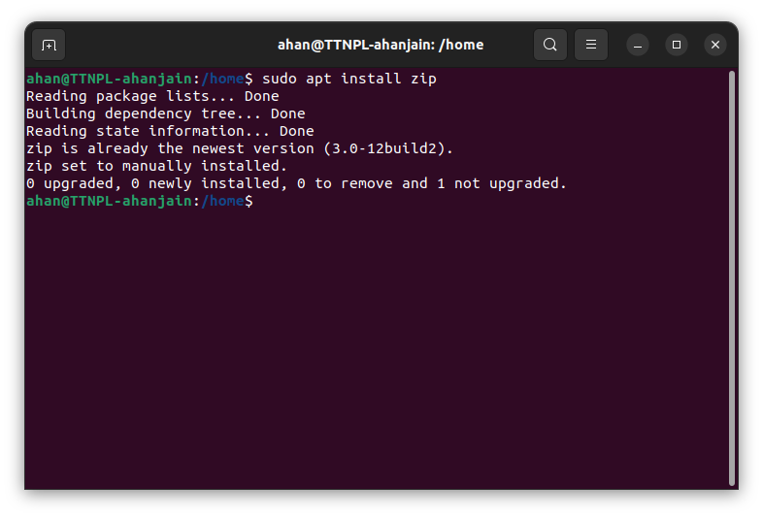

**14. Compress "output" and "password_backup" files into a tar ball. List the files present inside the tar created.**

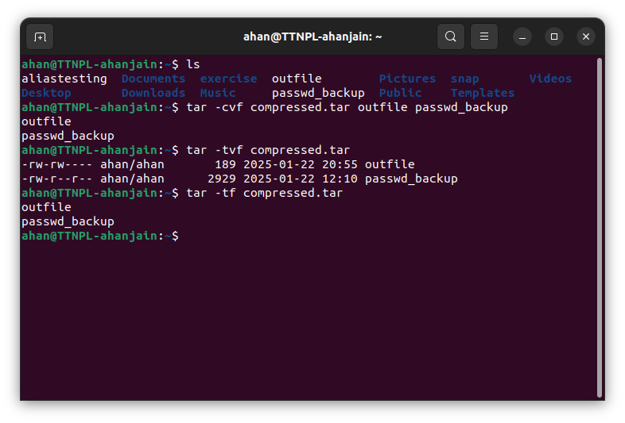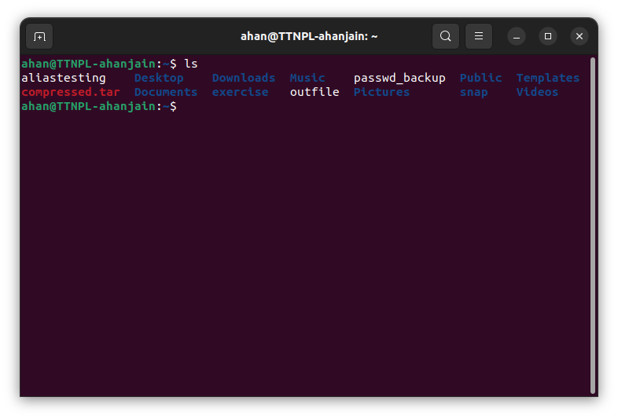

**15. scp this file to test user home location.**

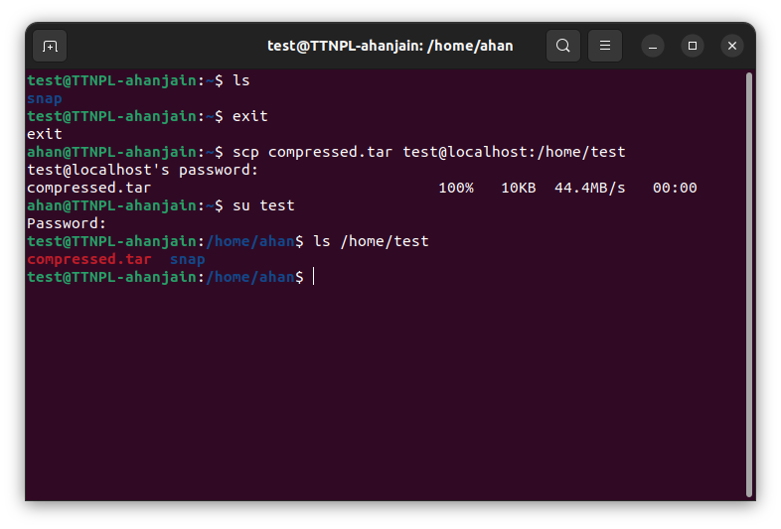

**16. Unzip this tar bar by logging into the remote server**

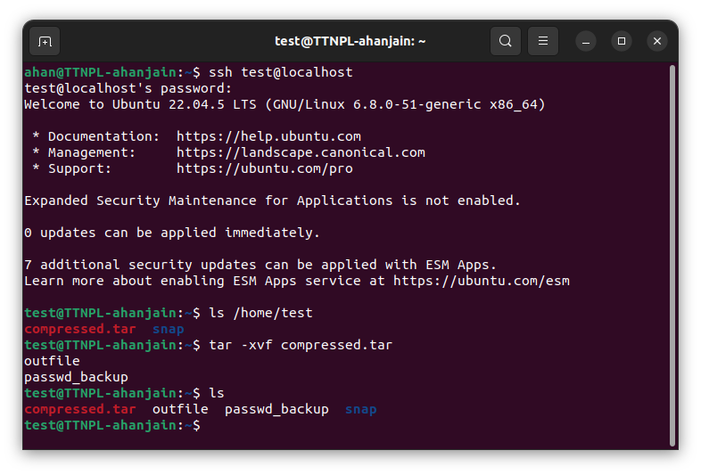

**17. Download(via cli) any image from web and move(via cli) to test user home location.**

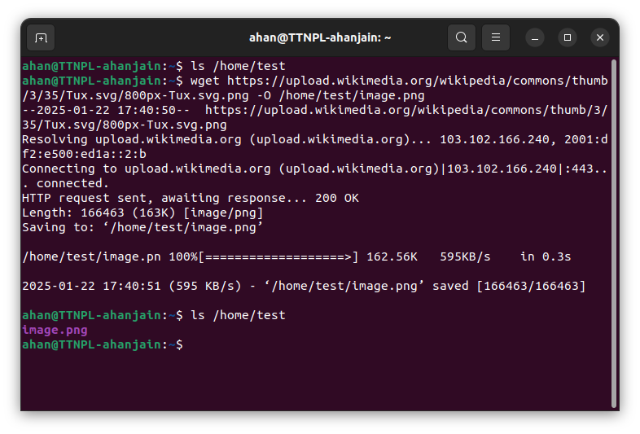

**18. How to get help of commands usages.**

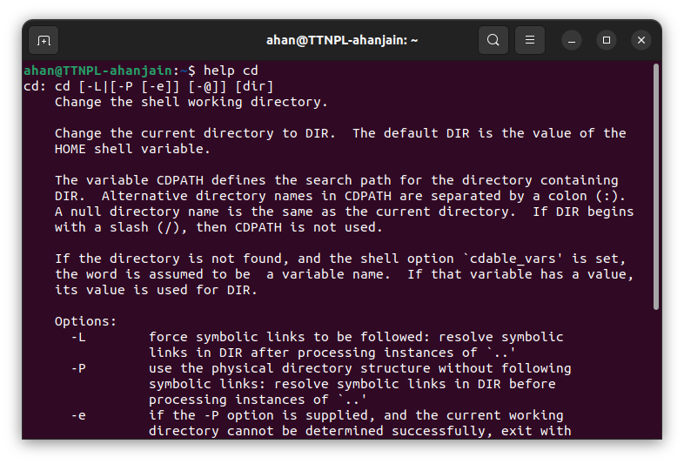

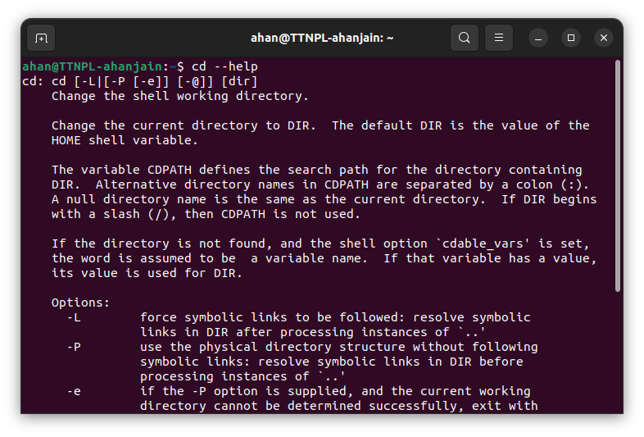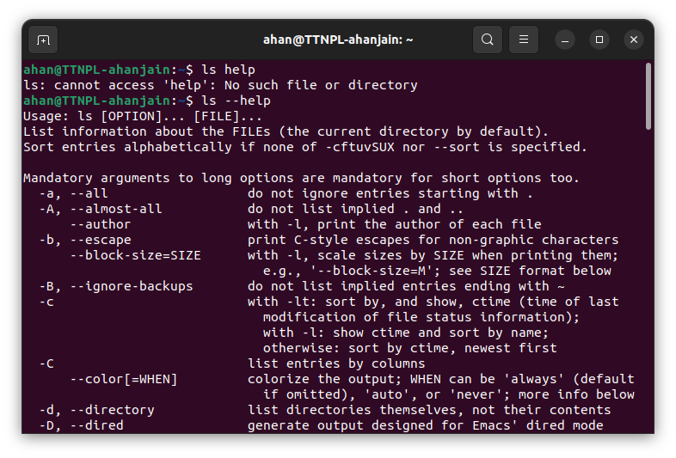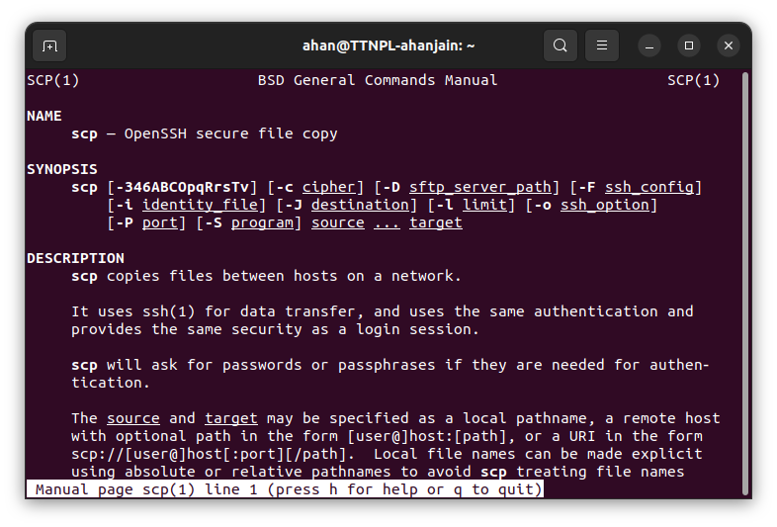

**19. Create a symlink of /etc/services into /tmp/ports-info**

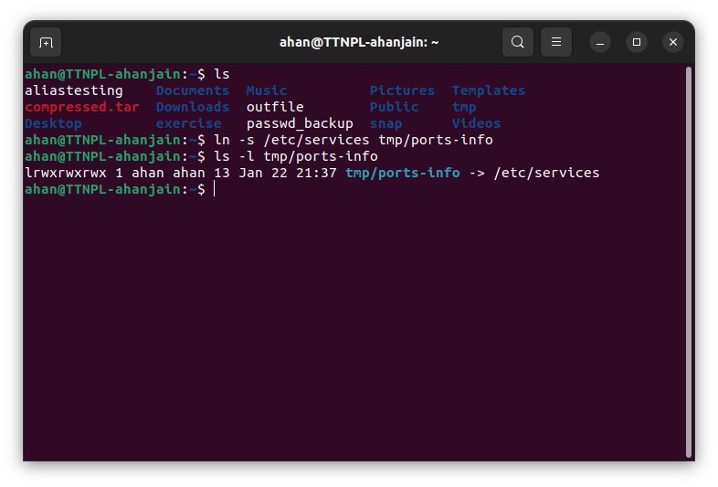

**21. Analyze the /var/log/syslog file to gather specific information.**

1. **Extract the last 10 lines from the syslog file that mention the word "cron."**

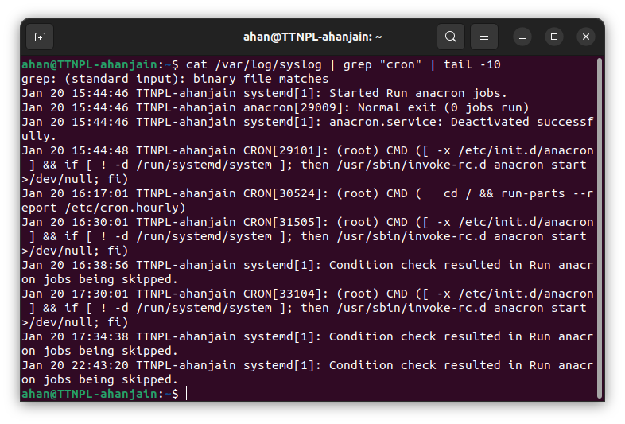

**b. Find and display the first 5 lines in the syslog file containing the keyword "error."**

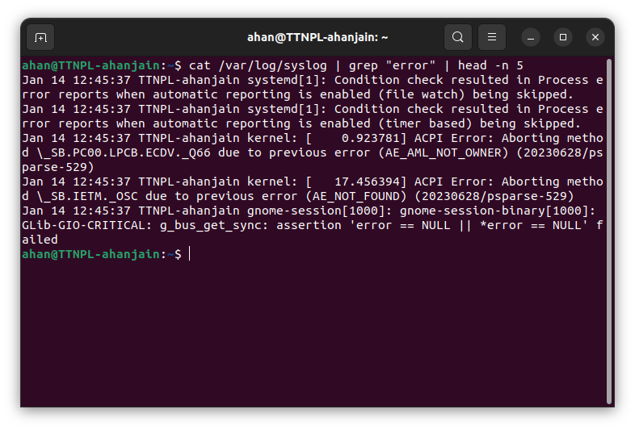

**c. Save the last 20 lines of the syslog file containing the word "ssh" to a new file named ssh_errors.log.**

